Checkout C4J from Google Code Mini How-To
Using Windows XP and Tortoise SVN
Carlos Quijano < carlos.quijano (at) commerc4j (dot) org >
Copyright © 2010 Carlos Quijano, Commerce4J Project
v2010.01 Jun 2010, released under Creative Commons License.

Abstract
this mini how-to is a simple tutorial about getting the Commerce4J project source code from Google Code and set-up a local working copy using Microsoft Windows as Operating System and Tortoise SVN as SVN graphical client tool.

- Choose a local folder from the file system; this will be the working copy. Using Tortoise SVN right-click the folder content and choose the “Checkout” option.
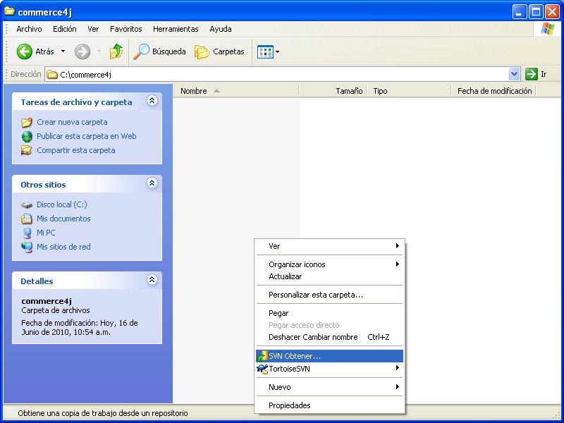
- Type the project repository Checkout URL* in the repository location text box, leave the default options and click “OK”
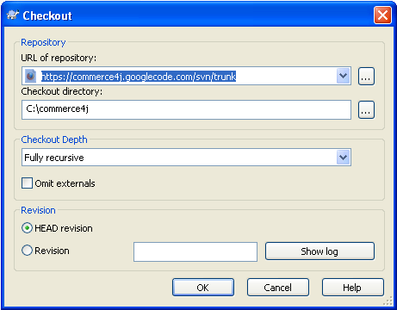
** The Project Checkout URL is
http://commerce4j.googlecode.com/svn/trunk
Instructions can be found in the Google Code project website
http://code.google.com/p/commerce4j/source/checkout
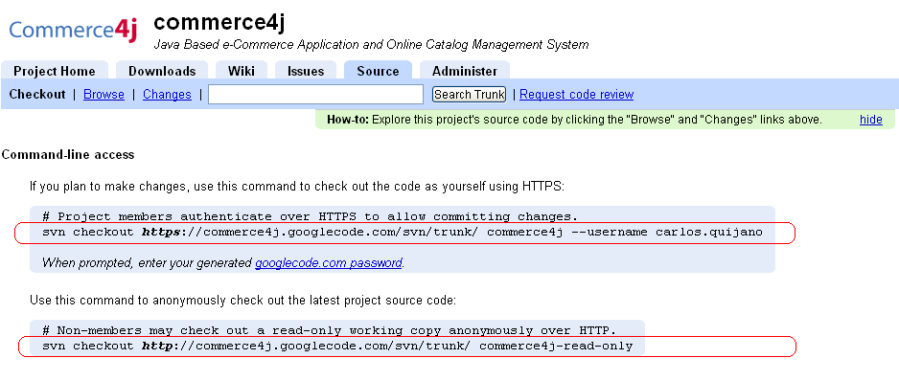
TortoiseSVN needs the URL’s in order to correctly checkout source code, Both URL’s are the same except for the URL’s protocol: HTTPS or HTTP, copy the Project Members HTTPS URL if you are an authorized member and may commit changes to the project source code, otherwise copy the Non-Member HTTP URL. Google Code will not allow you to commit changes from HTTP protocol.
- There should be a log window after check out, click OK.
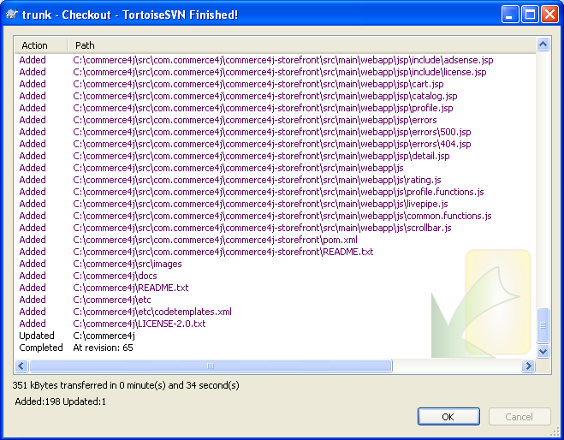
Your local working copy should be set up. Tortoise SVN won’t ask for any username and password until a commit is requested.
